

Win TWO nights dinner, bed & breakfast for two at At Double Tree by Hilton, Westerwood Spa & Golf Resort, Glasgow, G68 0EW

£2 | Name: ……………………………………………………………  Phone: …………………………………………………………..  Email: ……………………………………………………………. |  | £2 | Name: …………………………………………………..  Phone: ……………………………………………………  Email: …………………………………………………….
£2 | Name: ……………………………………………………………  Phone: …………………………………………………………..  Email: ……………………………………………………………. |  | £2 | Name: …………………………………………………..  Phone: ……………………………………………………  Email: …………………………………………………….
£2 | Name: ……………………………………………………………  Phone: …………………………………………………………..  Email: ……………………………………………………………. |  | £2 | Name: …………………………………………………..  Phone: ……………………………………………………  Email: …………………………………………………….
£2 | Name: ……………………………………………………………  Phone: …………………………………………………………..  Email: ……………………………………………………………. |  | £2 | Name: …………………………………………………..  Phone: ……………………………………………………  Email: …………………………………………………….
£2 | Name: ……………………………………………………………  Phone: …………………………………………………………..  Email: ……………………………………………………………. |  | £2 | Name: …………………………………………………..  Phone: ……………………………………………………  Email: …………………………………………………….

Please send completed tickets and cheque, made payable to ‘The Deerhound Club’, to the BREED SHOW SECRETARY – Sandra Cummings, 21 Danycoedcae Road, Pontypridd, South Wales, CF37 1LS by Friday 3 March 2023 draw to take place at Crufts 2023
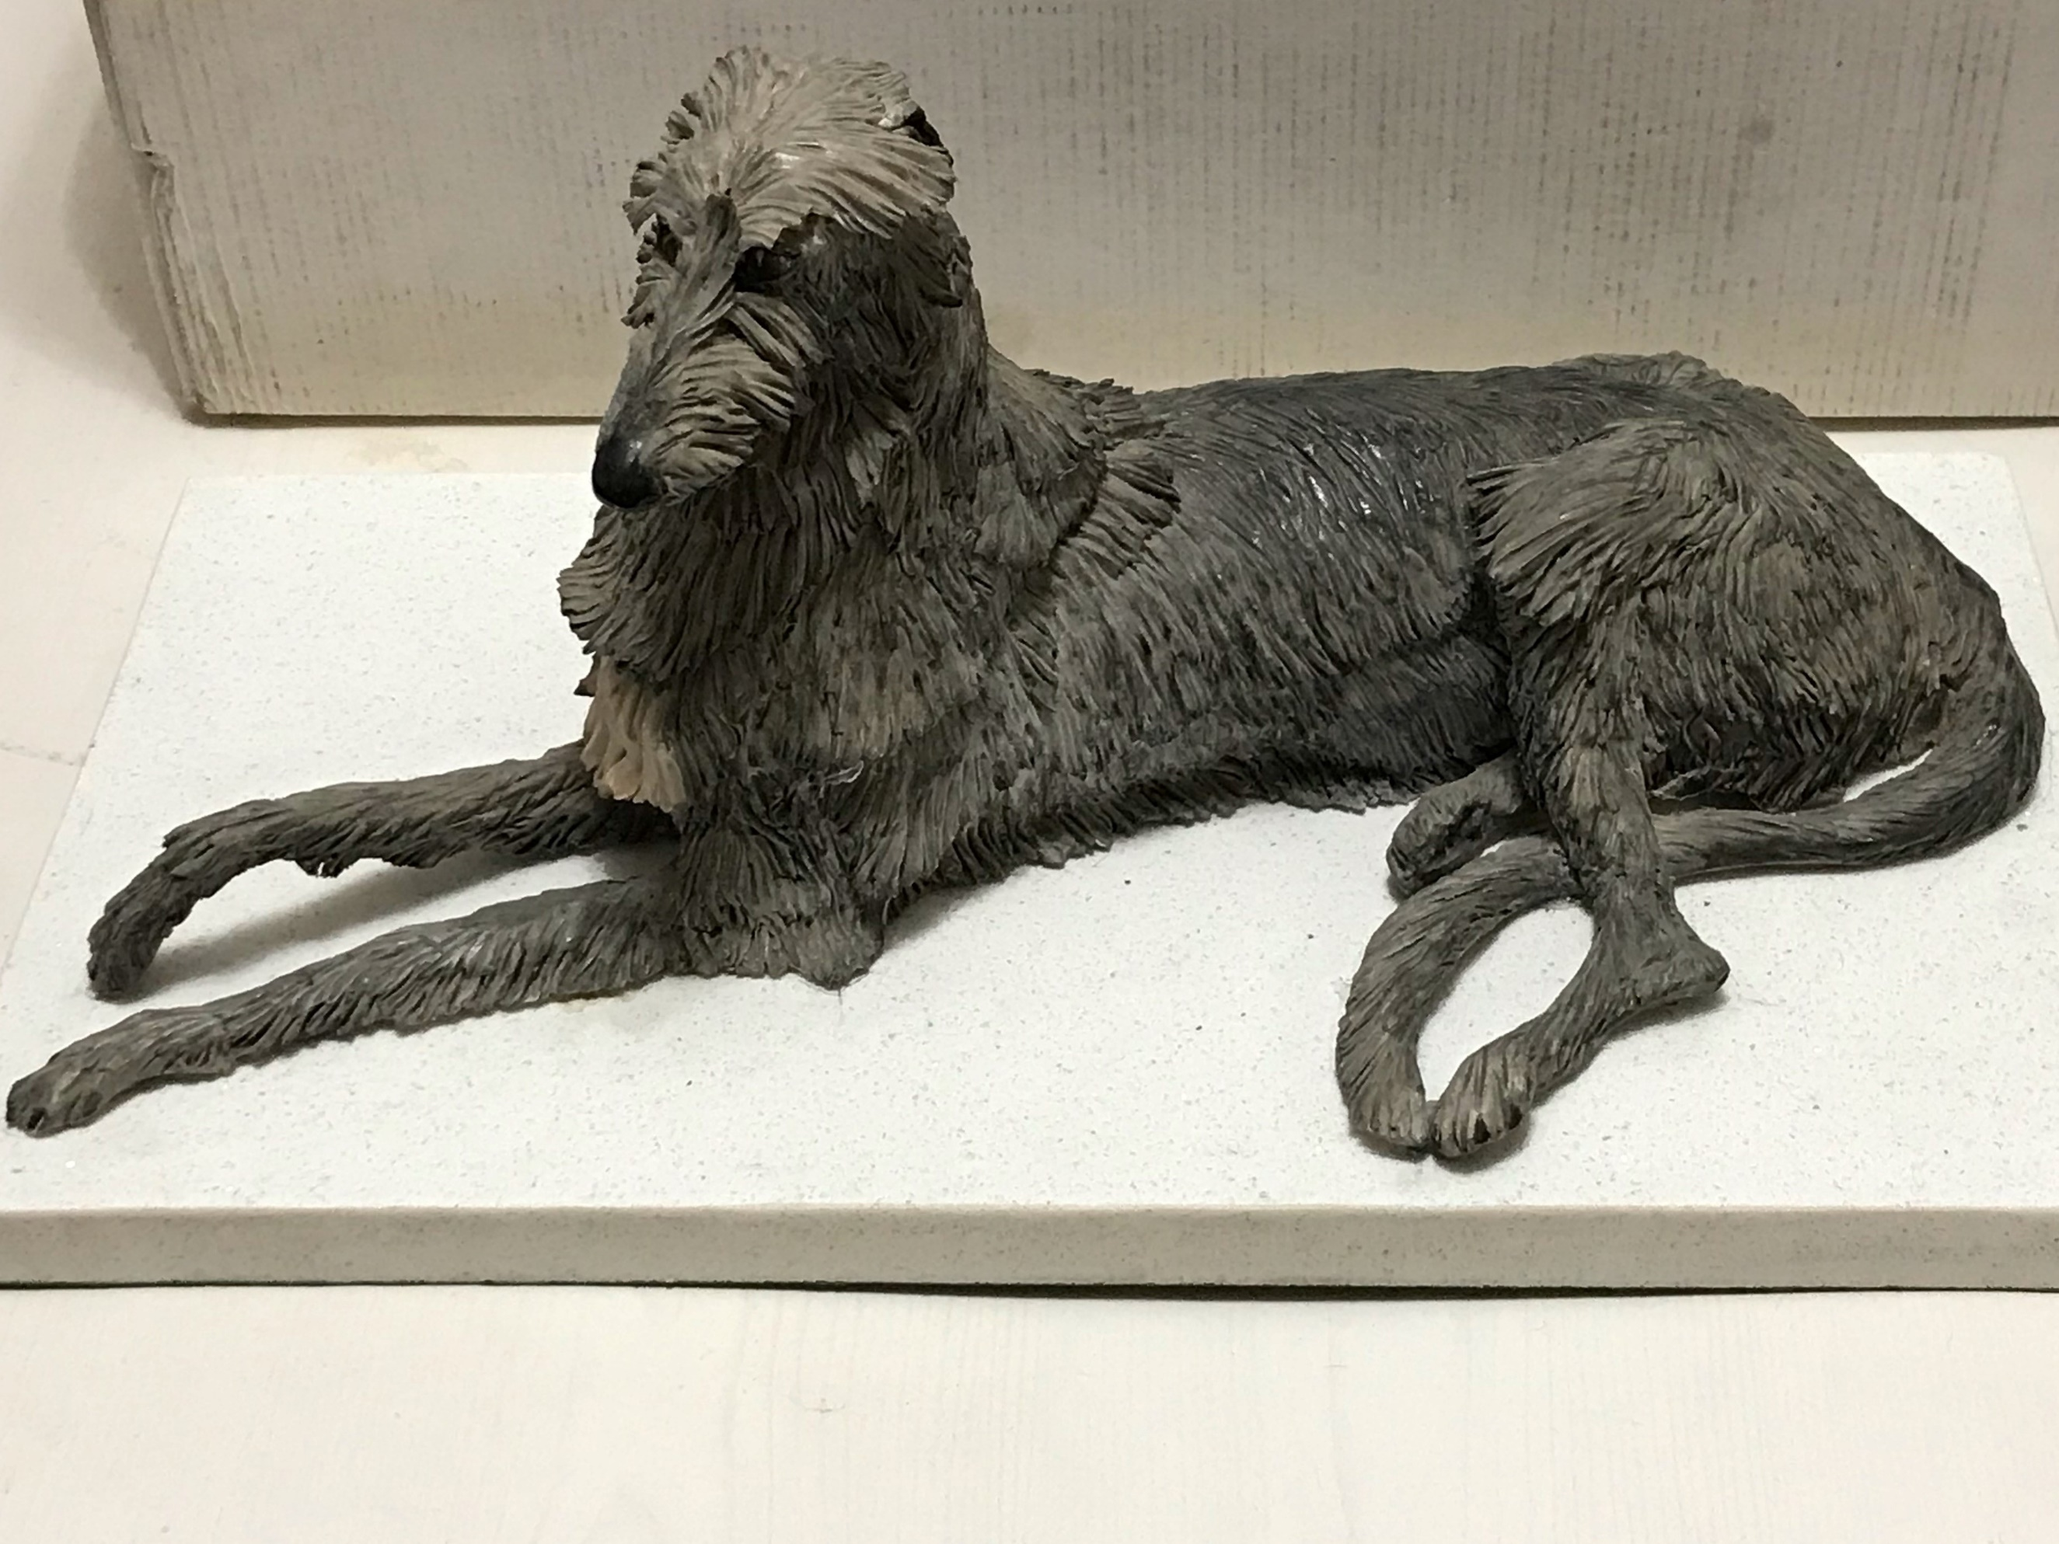
‘SPECIAL RAFFLE’
A porcelain model from Easthampstead Porcelain
from the estate of the late Mrs Mary Tully

£5 | Name: ……………………………………………………………  Phone: …………………………………………………………..  Email: ……………………………………………………………. |  | £5 | Name: …………………………………………………..  Phone: ……………………………………………………  Email: …………………………………………………….
£5 | Name: ……………………………………………………………  Phone: …………………………………………………………..  Email: ……………………………………………………………. |  | £5 | Name: …………………………………………………..  Phone: ……………………………………………………  Email: …………………………………………………….
£5 | Name: ……………………………………………………………  Phone: …………………………………………………………..  Email: ……………………………………………………………. |  | £5 | Name: …………………………………………………..  Phone: ……………………………………………………  Email: …………………………………………………….
£5 | Name: ……………………………………………………………  Phone: …………………………………………………………..  Email: ……………………………………………………………. |  | £5 | Name: …………………………………………………..  Phone: ……………………………………………………  Email: …………………………………………………….
£5 | Name: ……………………………………………………………  Phone: …………………………………………………………..  Email: ……………………………………………………………. |  | £5 | Name: …………………………………………………..  Phone: ……………………………………………………  Email: …………………………………………………….

Please send completed tickets and cheque, made payable to ‘The Deerhound Club’, to the BREED SHOW SECRETARY – Sandra Cummings, 21 Danycoedcae Road, Pontypridd, South Wales, CF37 1LS by Friday 7 April 2023 draw to take place at the Breed Show

